**LAB REPORT 3**

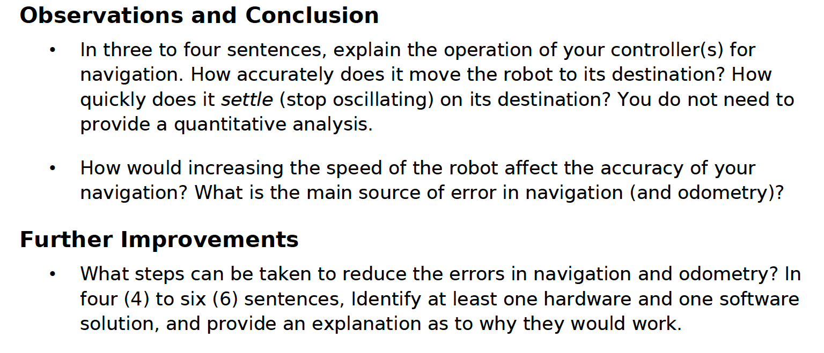

Observations and Conclusion

* In order for the robot to travel to a certain point, it continuously adjusts its trajectory’s angle and reads its position until it reaches the final destination. The threshold of the allowed error is set to be really small as to increase the accuracy of the robot. Since the odometer readings’ period is very short, the update of the current position robot updates frequently enough for the robot to be able to quickly settle. According to our trials, the robot does not oscillate before coming to a stop.
* In increasing the robots speed, the accuracy of navigation would decrease. Since the navigation is based upon the odometer’s outputs, the quicker the robot moves, the further it travels before the odometer’s reading updates. Hence, it might not have enough time to react. In other words, setting a small error to the final destination allows the robot to travel to it with a greater accuracy. Nevertheless, if the speed is too high, it might travel through the acceptable range of the terminal without having the chance read the positions, which would cause it to oscillates back and forth.

Further Improvements:

* Hardware:

The attachment of the ultrasonic sensor upon a motor would facilitate the wallFollower method. Wen following the wall, once the robot stops sensing a wall, it would be easier if it could turn the sensor in order to find a new wall. This method would also allow a more precise and efficient wallFollower.

* Software:

The implementation of an odometer correction could help increasing the precision of the readings of the robot. Although avoiding obstacle causes the robot to not move in a straight line from one point to another, the robot can calculate the overall angle it has turned in between two line and use it to correct its readings accordingly.